Thanksgiving
1. Watch the video about the first Thanksgiving in America.
Read the following sentences. Are they true or false?

1. The British king said that everybody had to use the same prayers that he did.
2. Some people were very unhappy.
3. Nothing would happen to those who did not obbey the king's orders.
4. A group of people decided to move to a country named Holland.
5. In Holland they were very unhappy but they had lots of money to spend.
6. They decided to move again and go to America.
7. They set out on a huge ship.
8. The ship that took the pilgrims to America was called the Mayflower.
9. The ship was crowded, cold and uncomfortable.
10. They travelled across the Atlantic for 5 months.
11. They arrived in December.
12. It was very cold and they were hungry and tired.
13. Many people died on their first winter in America.
14. The pilgrims met unfriendly natives who did not help them.
15. In spring Squanto, a native American, taught them how to plant barley, wheat and corn.
16. The pilgrims were unhappy because they would not have enough food to survive winter.
17. They had so much food that they decided to have a feast to celebrate their harvest.
18. The pilgrims prepared their feast but they did not invite the native Americans.
19. They ate wild ducks, geese, wild turkeys, deer meat, bread, cakes, fish and clams.
20. Before eating, pilgrims and native Americans thanked God for all His goodness.

2. Thanksgiving vocabulary.

a. Write the missing vowels to complete the words.
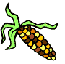 | 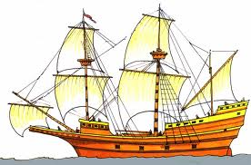 | 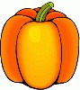 | 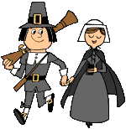 | 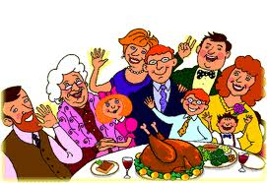
crn | Myflwr | pmpkn | plgrms | fmly
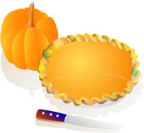 |  | 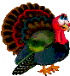 | 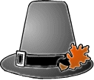 | 
pmpkn  p | tmn  lvs | trk | plgrm  ht | crnbrry  sc

b. Unscramble the words.

1. 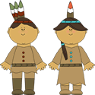 ivante mAreiacns
2. 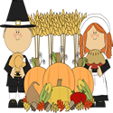 hTakginsvnig vesthar
3. 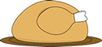 oocked urteky
4. 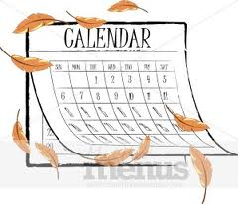 oNevmber
5. 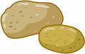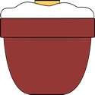 masehd poatotes
6. 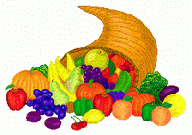 honr fo lpnety

