Endangered Animals

There are a lot of animals, but some of them are in danger because of the environment pollution, or people who kill them. Some species of animals in danger are:

- Magellanic penguin
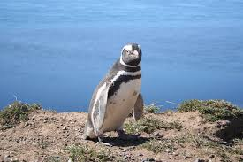
They are living in tropical forests of South America and they eat fish. Magellanic penguins are medium-sized penguins which grow to be 61–76 cm tall and weigh between 2.7 and 6.5 kg . Like other species of penguins, the Magellanic penguin has very strong wings used to swim under water.

- Panda
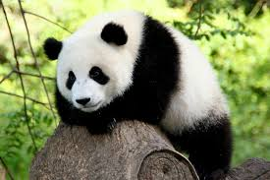
They are living in forests of China. Panda eat bamboo and they do not eat people. A panda male weighs from 300-400 pounds.

- South China tiger
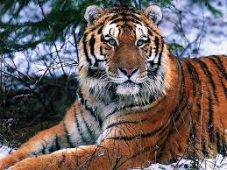
The South China tiger lives in zoos and is imprisoned in cages. It is a carnivore animal. There are around 59 south china tiger all over the world.

4. Mountain gorillas
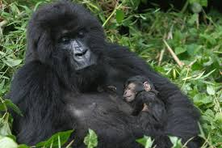
He lives in the mountains and is eating humans. There are still around 680 and they weigh about 220 pounds and 6 meters height.

5. Sea turtle
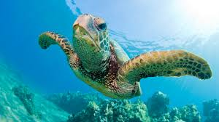
It lives in all oceans except the Arctic. It is in risk because of the pollution of seas. The greater Sea turtle is about 2 meters height and 10 pounds weight.

Ifigeneia and Katerina Foutsi

