|  |
| --- |
| **INTERNET SAFETY** |
|  |
|  |
| BETTER SAFE THAN SORRY |
|  |
| **KONSTANTINA –HARA SARANTI** |
| **29/11/2013** |
|  |

**INTERNET SAFETY**

**What is Internet?**



The web (world wide web: www) was invented in 1989 by a British computer scientist at CERN in Switzerland in order to help exchanging information between him and other scientists. A few years later, it evolved into the Internet. Internet is a tool that covers the whole world electronically with information and communication. Because information on the Internet moves at the speed of light, anyone can reach any information (e.g. science, world news, movies, music, games) in a second from enormous databases and communicate with web sites and people. It is a huge window in the world at home and everyone uses it for different reasons. Any one becomes part of the Internet world because everything is new right now.

Addiction to Internet?



On the other hand, Internet hides a lot of dangers for all the ages. A recent survey in a medical journal shows that addiction to the Internet approaches high percentages similar to the alcoholism. For this reason, the behaviour of people addicted to the Internet resembles that of those addicted to alcohol. People who are addicted to the Internet check continuously their Face book, their email for announcements, are in websites for no reason and in chat rooms for hours. The characteristics that often show the addiction to the Internet are the following: the lack of attention, social phobia, the lack of imagination, reduction of other activities (e.g. school, relationships, job) indifference to sleep and eat, shyness that lead to the adoption of a new identity that creates a form of sociality in a virtual reality and not in the true one.

Besides these, there are greater dangers in the Internet except addiction to it because Internet offers an anonymity that leads some to behave abusively online, in ways you would never consider in the real world.

**Who are the dangers in Internet for all ages?**

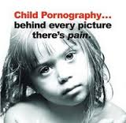

Websites with pornographic subjects which mislead all the users of all ages at any time. Particularly, children porno-graphy is too widespread and of course is a crime and for this reason is punished hard from the law. People who deal with pornography contact children through chat rooms and Face book, they take information after they have taken children confidence and persuade children to make obscene photos.



Websites with violent games which push the players to kill anyone shown in front of them. In this way, the children’s behaviour becomes violent in real life.



Websites with gambles where someone can play with real money by using his credit card. There are many examples of people who destroyed themselves and their family.



Advertisements that continuously are presented in front of the user. In this way, the user is misled to false needs and com-merce opportunities that usually lead users to useless purchases and debts.

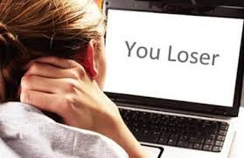

Cyber bullying phenomenon is another danger, especially for young people who don’t have the experience to understand what is false or not. It is presented with the form of a false profile with fake information and fake news, fake photos, sending e-mails with unpleasant or threatening messages, racist or sexist hinds and inviting people to take part in a group whose purposes are illegal and hazard. It is very difficult for the visitors of such sites to break off the contact with them because they are bombarded 24 hours a day.

#### https://encrypted-tbn3.gstatic.com/images?q=tbn:ANd9GcQrXN3WKnj5BAwQdGQida3-F2HvwEF3cw3BZFRB16c5qFt3v6G1SA

#### Malware is malicious and anonymous legitimate software which in fact is a spy. It is made through e-mail and files from unofficial locations. It is very difficult to indentify if a file is infected because no one knows the source of the file. It is designed to collect and transmit private information such as passwords, usernames and credit card details without the user's consent or knowledge.

**Close relationship of high school teenagers with internet and results of this?**

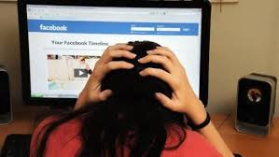

Unfortunately teenagers today live their lives in the Internet. They watch their favorite singers; they upload their favorite songs from YouTube. They check all the time their friends’ status updates and post their own information without realizing that this information can go out to friends, strangers, and companies who will target to their location. They also upload photos and videos without knowing that nothing can disappear from the Internet. Moreover, they play games without time limits, they are in chat rooms for hours, they explore sites that cover their interests but they don’t know when they must stop exploring them and they make new online connections by accepting new friends in Face book without checking if these “friends” are appropriate people.

What parents have to do about their children Internet safety?

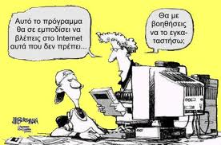

1. They should be close to their children in life.

2. They must accept that Internet is a tool of knowledge.

3. Computer must be in a visible area of the house, not in children’s room.

4. They have to know that online relations can really affect their children’s life now and in future because privacy and reputation aren’t secure in the Internet e.g. a secret to a friend can be a headline in Face book. So they must educate their children about their internet safety and privacy.

5. They can join in most Internet activities with their children.

6. They must reduce the possibility of their children reaching offensive sites by using [parental controls](http://en.wikipedia.org/wiki/Parental_controls). Parental controls allow children and parents to set filters on their computers while using the internet since filters limit the access to inappropriate sites.

7. They must put time limits in Internet surfing.

8. They have to teach their children how to protect themselves from internet anonymous approaches or sites or advertise-ments and mention any suspicious incident to them immediately without having fear of their reaction.

BIBLIOGRAPHY

**WIKIPEDIA**

**internet-safety.sch.gr/‎**

**www.fbi.gov**

[**www.commonsensemedia.org/**](http://www.commonsensemedia.org/)

[**www.newsit.gr**](http://www.newsit.gr)

[**http://www.christianity-science.gr**](http://www.christianity-science.gr)

Newspaper: Ελευθεροτυπία (Written by Dr. N. THEOTOKA ILIA, clinical psychologist, psychotherapist, Psychiatric Clinic, University of Athens, Aeginition Hospital)

