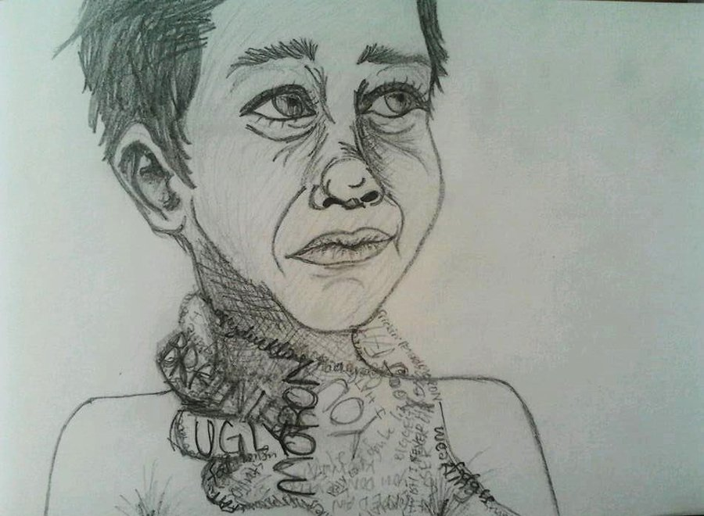***BULLYING AND ANTI-BULYING***

A project by:

Marios Tagaris

Class: Γ’4adv.

2013-2014

***introduction***

* Nowadays, we can see lots of kids and adults, of course, “playing” the role of the victim abused from violence.
* In this project, we can inform you about this fact. Specifically, we are going to talk about bullying and anti-bullying.
* To be precise, we are going to talk about the roles of the people involved, we will “bring” examples about them and of course what must be done to end this terrible thing…!!!

***Bullying: What it is and how to deal with it***

* Every day, thousands of teens wake up afraid to go wherever they must go (e.g. school, gym etc.). We can say that this is the “basic” result of bullying. Unfortunately, parents and teachers can’t see it clearly, so they don’t even know how “powerful” bullying can get…
* Specifically, bullying is when a person (probably a teenager) is picked on by an other person or a group of them with more power.

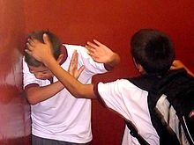

***types of bullying***

First of all, we can see many types of bullying, like cyber bullying or psychological bullying. To be more specific:

* In cyber bullying someone can send cruel messages or texts with swears. The most usual thing is the posting insults about a person on different sites of communication, like Facebook or Twitter.
* In psychological bullying someone can bully people they categorize as different by gossiping about them.

***stop bullying…***

Like I said, bullying can harm many people and, of course, can affect their psychology. The effects can last well into adulthood…So, it is very important for us and for all adults to understand that bullying does not have to be a normal part of childhood !!!

***STOP BULLYING RIGHT NOW!!!!***

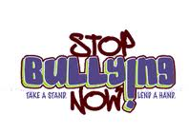

***Anti-bullying celebration***

So, supporters from all over the world, have made a campaign called “**anti-bullying**”. To be more explicit, it is an “event” in the third week of November, which aims to raise awareness of bullying among young people in places they frequent (e.g. schools).We thank anybody who helps to end this terrible thing, especially at schools…!!!

***BE BRAVE…SPEAK OUT !!!***

***Bibliography***

* ***Wikipedia.org***
* ***Kids health .com***
* ***Education.com***

***THANKS FOR YOUR TIME…I APPRECIATE IT…!!!***