**4th  JUNIOR HIGH SCHOOL OF METAMORFOSIS**

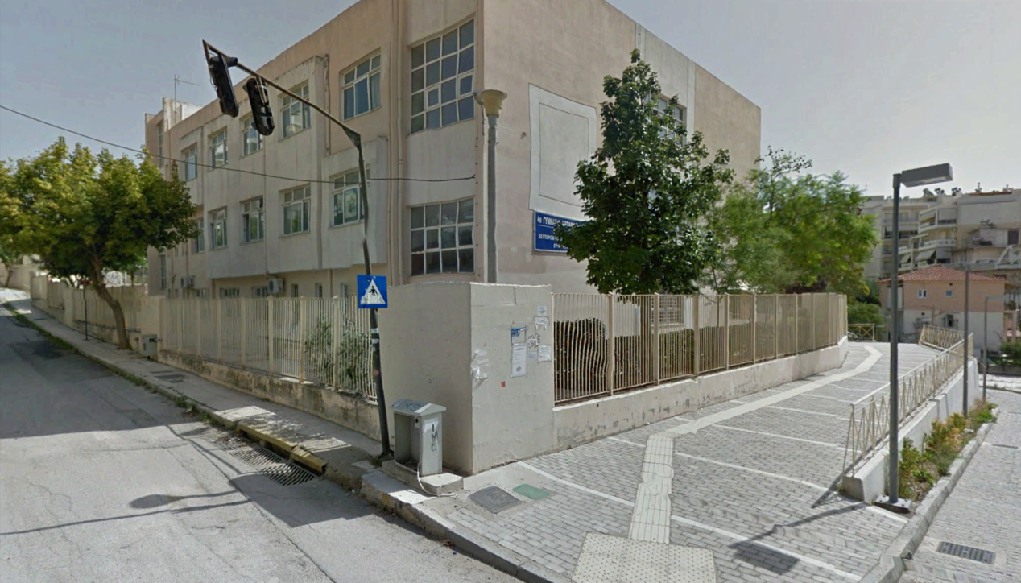

The building was constructed in 2000 and has been used exclusively by the school. It is well preserved and without major problems. It has adequate and functional facilities with access for the disabled, a basketball court and a 5x5 football pitch, classrooms, staff rooms and laboratories. More specifically, it has ten airy and bright classrooms on the first and second floor, a digital classroom with an interactive whiteboard and 24 tablets, a computer lab, a technology classroom, a science lab, halls, a canteen, warehouses and an indoor gym with ventilation on the basement. The science laboratory has many shortcomings that hinder the realization of experiments. We need to construct two more classrooms and one room to be used as for students with learning difficulties. There are two computers available for the teachers, a computer in the principal's office and a laptop on the deputy's office, two landlines, a fax and two Xerox machines.

